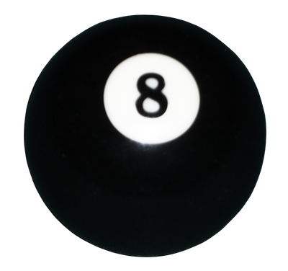
Entry Fee
includes a wrist band
$2.00 can beers and
$0.50 cents off alcohol drinks.
Door Prize Ticket
Malvern Moose Lodge #2365
8 Ball Double Elimination Pool Tournament
Race to 2
$40.00 per player
Signups Start at 1pm
Tournament Starts at 2:30pm
64 players maximum
$200.00 Guaranteed 1st place

Will pay 3 places
Bobby J Smith
Memorial Pool Tournament
March 7th, 2026
AMA State Fundraiser

Kitchen Will be open
Special Menu

